Written Assignment 6

Godfrey Ouma
University of the People
MATH 1211: Calculus
Rakesh Das
December 27, 2023

Written Assignment 6
1. An airplane is flying towards a radar station at a constant height of $6 km$ above the ground. If the distance s between the airplane and the radar station is decreasing at a rate of $400 km$ per hour when $s=10 km$, what is the horizontal speed of the plane? Make sure your answer includes units.
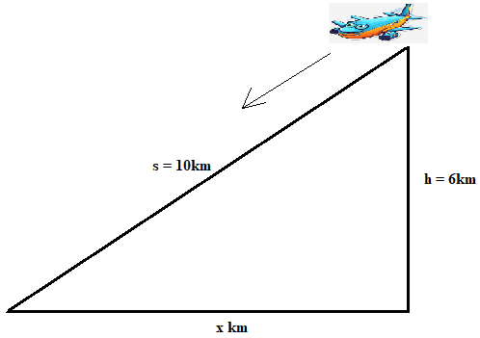
By Pythagoras theorem, ${[s\left(t\right)]}^{2}=6^{2}+{[x\left(t\right)]}^{2}$ …………………..(i)
Performing derivative with respect to time on both sides
${\frac{d}{dt}[s\left(t\right)]}^{2}=\frac{d}{dt}6^{2}+{\frac{d}{dt}[x\left(t\right)]}^{2}$
$2s\frac{ds}{dt}=0+2x\frac{dx}{dt}$
$s\frac{ds}{dt}=x\frac{dx}{dt}$ ………………………...(ii)
$x=\sqrt{s^{2}-h^{2}}$
$x=\sqrt{{10}^{2}-6^{2}}$
$x=\sqrt{64}=8km$
Substituting $s=10km$, $\frac{ds}{dt}=-400 km/h$, and $x=8km$ into equation (ii)
$(10km)(-400km/h)=(8km)\frac{dx}{dt}$
$\frac{dx}{dt}=\frac{(10km)(-400km/h)}{8km}=-500km/h$
Since speed is a scalar quantity, we take the absolute value of $-500km/h$. Therefore, the horizontal speed of the plane $=\left|-500km/h\right|=500km/h$
2. A boat is being pulled into a dock by a rope attached to it and passing through a pulley on the deck, positioned 6 meters higher than the boat. If the rope is being pulled in at a rate of 3 meters/sec, how fast is the boat approaching the dock when it is 8 meters from the dock? Make sure your answer includes units.
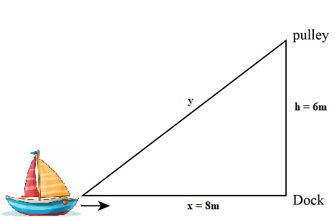
By Pythagoras theorem, ${[y\left(t\right)]}^{2}=6^{2}+{[x\left(t\right)]}^{2}$ …………………..(i)
Performing derivative with respect to time on both sides
${\frac{d}{dt}[y\left(t\right)]}^{2}=\frac{d}{dt}6^{2}+{\frac{d}{dt}[x\left(t\right)]}^{2}$
$2y\frac{ds}{dt}=0+2x\frac{dx}{dt}$
$y\frac{dy}{dt}=x\frac{dx}{dt}$ ………………………...(ii)
$y=\sqrt{x^{2}+h^{2}}$
$y=\sqrt{8^{2}+6^{2}}$
$y=\sqrt{100}=10m$
Substituting $y=10m$, $\frac{dy}{dt}=3m/s$, and $x=8m$ into equation (ii)
$(10m)(3m/s)=(8m)\frac{dx}{dt}$
$\frac{dx}{dt}=\frac{(10m)(3m/s)}{8m}=3.75m/s$
3. A girl is flying a kite on a string. The kite is 120 ft. above the ground and the wind is blowing the kite horizontally away from her at 6 ft/sec. At what rate must she let out the string when 130 ft of string has been released? Make sure your answer includes units.
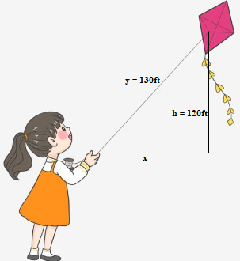
By Pythagoras theorem, ${[y\left(t\right)]}^{2}={120}^{2}+{[x\left(t\right)]}^{2}$ …………………..(i)
Performing derivative with respect to time on both sides
${\frac{d}{dt}[y\left(t\right)]}^{2}=\frac{d}{dt}{120}^{2}+{\frac{d}{dt}[x\left(t\right)]}^{2}$
$2y\frac{ds}{dt}=0+2x\frac{dx}{dt}$
$y\frac{dy}{dt}=x\frac{dx}{dt}$ ………………………...(ii)
$x=\sqrt{y^{2}-h^{2}}$
$x=\sqrt{{130}^{2}-{120}^{2}}$
$x=\sqrt{2500}=50ft$
Substituting $x=50ft$, $\frac{dx}{dt}=6ft/s$, and $y=130ft$ into equation (ii)
$(130ft)\frac{dy}{dt}=(50ft)(6ft/s)$
$\frac{dx}{dt}=\frac{(50ft)(6ft/s) }{130ft}=2.31ft/s$
4. Find the Linearization of $f\left(x\right)=sinx$ at $a=\frac{π}{2}$. Provide your answer as $L\left(x\right)=$ ?
$L\left(x\right)=f\left(a\right)+f^{'}\left(a\right)(x-a)$ …………………..(i)
$f\left(a\right)=\sin\left(\frac{π}{2}\right)=1$
${ f}^{'}\left(a\right)=cos\left(\frac{π}{2}\right)=0$
Substituting $a$, $f(a)$ and $f'(a)$ into equation (i),
$L\left(x\right)=1+0\left(x-\frac{π}{2}\right)=1$
5. Use Linear Approximation to estimate $e^{(-0.01)}$. Provide your answer in 2 decimal places. Do not use a calculator. Show work for credit.
Given $a=0$ and $f\left(x\right)=e^{x}$,
$L\left(x\right)=f\left(a\right)+f^{'}\left(a\right)(x-a)$ …………………..(i)
$f\left(a\right)=e^{0}=1$
${ f}^{'}\left(a\right)=e^{0}=1$
Substituting $a$, $f(a)$ and $f'(a)$ into equation (i),
$L\left(x\right)=1+1\left(x-0\right)$
$L\left(x\right)=1+x$
$L\left(-0.01\right)=1+\left(-0.01\right)=0.99$
6. Calculate the locations of maximums and minimums of the following functions: Show work in details.
- $f\left(x\right)=x^{3}-3x+2$
$f^{'}\left(x\right)=3x^{2}-3$
Taking $3x^{2}-3=0$, the critical point becomes $x=1$ and $x=-1$.
Critical point ($x$) | $$f(x)$$ | Conclusion
1 | $$f\left(1\right)={(1)}^{3}-3\left(1\right)+2=0$$ | Local minimum
-1 | $$f\left(-1\right)={(-1)}^{3}-3\left(-1\right)+2=4$$ | Local maximum
- $f\left(x\right)=x^{4}-8x^{2}+3$
$f^{'}\left(x\right)=4x^{3}-16x$
Taking $4x^{3}-16x =0$, the critical point becomes $x=0$, $x=2$ and $x=-2$.
Critical point ($x$) | $$f(x)$$ | Conclusion
-2 | $$f\left(-2\right)={(-2)}^{4}-8({-2)}^{2}+3=-13$$ | Global minima
0 | $$f\left(0\right)={(0)}^{4}-8({0)}^{2}+3=3$$ | Local maximum
2 | $$f\left(2\right)={(2)}^{4}-8({2)}^{2}+3=-13$$ | Global minima

7. Find the exact x-value where the function $f\left(x\right)=x+ln(x^{2}-1)$ attains a maximum value. An estimated answer or a calculator answer will not earn any credit.
$${ f}^{'}\left(x\right)=1+\frac{2x}{x^{2}-1}$$
$=\frac{x^{2}+2x-1}{x^{2}-1}$ for $x≠1$
$f\left(x\right)$ attains a maximum value at $f^{'}\left(x\right)=0$
$$\frac{x^{2}+2x-1}{x^{2}-1}=0$$
$$x^{2}+2x-1=0$$
$$x=\frac{-2±\sqrt{2^{2}-4(1)(-1)}}{2(1)}$$
$$=\frac{-2±\sqrt{8}}{2}$$
$$=\frac{-2±2\sqrt{2}}{2}$$
$$=-1±\sqrt{2}$$
Therefore, $f\left(x\right)=x+ln(x^{2}-1)$ will attain a maximum value at:
$x=-1+\sqrt{2}$ and $x=-1-\sqrt{2}$
8. Using the Mean Value Theorem and Rolle’s Theorem, show that $x^{3}+x-1=0$ has exactly one real root.
$$f^{'}\left(x\right)=3x^{2}+1$$
Setting $f^{'}\left(x\right)=0$,
$$3x^{2}+1=0$$
$$x^{2}=-\frac{1}{3}$$
$$x=\sqrt{-\frac{1}{3}}$$
There is no solution in real numbers, hence the function neither has local maxim nor local minima. Now let us test with $x=1$ and $x=-1$ to solve for $f(x)$ since we cannot work with $x=0$ as the critical value.
$$f\left(1\right)={(1)}^{3}+(1)-1=1$$
$$f\left(-1\right)={(-1)}^{3}+\left(-1\right)-1=-3$$
Based on the values of $f(1)$ and $f(-1)$ above, there must be a point $c$, $-1 < c < 1$ where $f(c) = 0$ since it has been proven that $f(-1) < 0$ and $f(1) > 0$. Thus, the function is continuous with only one real root.
9. If $f\left(1\right)=10$ and $f'(x)≥2$ for $1≤x≤4$, how small can $f(4)$ possibly be?
Applying the mean value theorem,
$$f^{'}\left(c\right)=\frac{f\left(b\right)-f(a)}{b-a}$$
Taking $a=1$ and $b=4$, and $f'(c)≥2$,
$$\frac{f\left(4\right)-f(1)}{4-1}≥2$$
$$f\left(4\right)-f(1)≥6$$
But $f\left(1\right)=10$,
$$f\left(4\right)-10≥6$$
$$f\left(4\right)≥16$$
10. The graph of a function is given below. Determine the intervals on which the function is concave up and concave down.
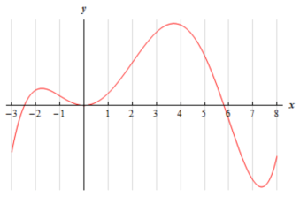
Concave down: (-3, -1) and (2, 6).
Concave up: (-1, 2) and (6, 8).

